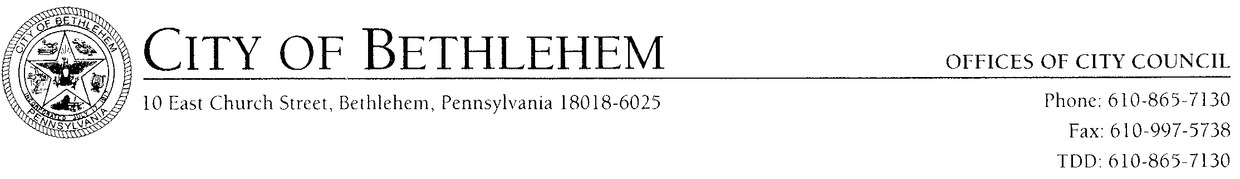

City of Bethlehem Memorandum
TO: Robert J. Donchez, President of Council

FROM: Dennis W. Reichard, Business Administrator

SUBJECT: Tabled Items – Council Agenda

Attached is an e-mail from Alex Karras indicating that the City tax records are backed up in the computer system.

Also attached is an e-mail from Mary Jo Reed indicating that the purchasing records requested to be destroyed are backed up in the computer system.

I am requesting that tabled items authorizing records destruction in the Bureau of Purchasing and Tax Bureau on the July 15th Council Agenda be removed from tabled items and a resolution be approved by City Council to have those records destroyed.

DWR:pah

Attachment

cc: Mayor Callahan
Members of Council
C. Spadoni
J. Spirk
Alex Karras
Mary Jo Reed
Meg Holland, Controller

July 25, 2008 _____________________________________
Dennis W. Reichard
Business Administrator

